

A
Project Report
on
Dyslexis
submitted as partial fulfillment for the award of
BACHELOR OF TECHNOLOGY
DEGREE
SESSION 2025-26
in
Computer Science and Engineering (AI)
By
Kanak Agrawal (2200291520093)
Gargi Kaushik (2200291520074)
Sarthak Sharma (2200291520158)

Under the supervision of
Ms. Anjali Maurya
KIET Group of Institutions, Ghaziabad
Affiliated to
Dr. A.P.J. Abdul Kalam Technical University, Lucknow
(Formerly UPTU)
May, 2026

DECLARATION
We hereby declare that this submission is our own work and that, to the best of our knowledge and belief, it contains no material previously published or written by another person nor material which to a substantial extent has been accepted for the award of any other degree or diploma of the university or other institute of higher learning, except where due acknowledgment has been made in the text.

Kanak Agrawal (2200291520093)
Gargi Kaushik (2200291520074)
Sarthak Sharma (2200291520158)

Date:

CERTIFICATE

This is to certify that Project Report entitled “Dyslexis” which is submitted by Kanak Agrawal, Gargi Kaushik and Sarthak Sharma in partial fulfillment of the requirement for the award of degree B. Tech. in Department of CSE (AIML) of Dr. A.P.J. Abdul Kalam Technical University, Lucknow is a record of the candidates own work carried out by them under my supervision. The matter embodied in this report is original and has not been submitted for the award of any other degree.

Supervisor Name Dr. Rekha Kashyap
(Designation) Dean – CSE (AI/AI&ML)

Date:

ACKNOWLEDGEMENT

It gives us a great sense of pleasure to present the report of the B. Tech Project undertaken during B. Tech. Final Year. We owe special debt of gratitude to Ms. Anjali Maurya, Department of CSE(AI), KIET, Ghaziabad, for his constant support and guidance throughout the course of our work. His sincerity, thoroughness and perseverance have been a constant source of inspiration for us. It is only his cognizant efforts that our endeavors have seen light of the day.
We also take the opportunity to acknowledge the contribution of Dr. Rekha Kashyap, Dean of the Department of Computer Science & Engineering (AI/AI&ML), KIET, Ghaziabad, for his full support and assistance during the development of the project. We also do not like to miss the opportunity to acknowledge the contribution of all the faculty members of the department for their kind assistance and cooperation during the development of our project.
We also do not like to miss the opportunity to acknowledge the contribution of all faculty members, especially faculty/industry person/any person, of the department for their kind assistance and cooperation during the development of our project. Last but not the least, we acknowledge our friends for their contribution in the completion of the project.

Date:
Kanak Agrawal (2200291520093)
Gargi Kaushik (2200291520074)
Sarthak Sharma (2200291520158)

ABSTRACT

Dyslexia is one of the most common learning disorders affecting reading, writing and language processing in children, often leading to academic difficulties and reduced confidence in traditional learning environments. Traditional teaching methods often lack personalization and engagement, which limits their effectiveness. This paper proposes a gamified learning platform that integrates interactive educational games with a convolutional neural network-based handwriting analysis model for the early detection of dyslexia. The system includes behavioral tracking and adaptive learning pathways to support cognitive and emotional development. Experimental evaluation on a labelled dataset shows an accuracy of 84.6% with a precision of 0.82, a recall of 0.80 and an ROC AUC of 0.87. The results demonstrate that the proposed approach improves both learning engagement and prediction performance, making it suitable for inclusive education environments. Conventional teaching approaches primarily rely on repetitive exercises and lack interactive elements, which may not effectively support learners with dyslexia. This paper presents Dyslexis, a gamified learning platform designed to support the cognitive, emotional and academic development of dyslexic learners through interactive educational games and intelligent analytics. The system integrates adaptive game modules targeting phonological awareness, vocabulary building, reading comprehension, visual–motor coordination and emotional engagement. In addition, an AI-based handwriting analysis model is incorporated to assist in early dyslexia prediction using a convolutional neural network (CNN). The platform also includes behavioural tracking mechanisms that monitor user engagement, response patterns and learning progress to provide personalized insights for educators and parents. Experimental evaluation of the handwriting prediction model achieved an accuracy of 84.6%, demonstrating the feasibility of integrating predictive analytics within an interactive learning ecosystem. The proposed approach highlights the potential of combining gamification and artificial intelligence to create a supportive and engaging learning environment for children with dyslexia, enabling both skill development and early identification within a unified platform.

TABLE OF CONTENTS | Page No.
DECLARATION……………………………………………………………………. | ii
CERTIFICATE……………………………………………………………………… | iii
ACKNOWLEDGEMENT..…………………………………………………………. | iv
ABSTRACT………………………………………………………………………..... | v
LIST OF FIGURES…………………………………………………………………. | iix
LIST OF TABLES…………………………………………………………………… | ix
LIST OF ABBREVIATIONS………………………………………………………. | x
CHAPTER 1 (INTRODUCTION)…………………………………………………. | 1
1.1. Introduction……………………………………………………………………... | 1
1.2. Project Description……………………………………………………………… | 2
CHAPTER 2 (LITERATURE REVIEW)…………………………………………. | 5
2.1. Understanding Dyslexia and Its Cognitive Foundations………………………... | 5
2.2. Gamification as a Learning Intervention............................................................... | 6
2.3. Artificial Intelligence in Dyslexia Detection.…………........................................ | 7
2.4. Comparative Analysis and Research Gap……………………………………….  CHAPTER 3 (PROPOSED METHODOLOGY) ….................................................. | 7  9
3.1. System Architecture……………………............................................................. | 9
3.2. Data Processing and Machine Learning…………………………………………  3.3. Gamification Design Principles………………………………………………….  3.4. Mathematical Formulations……………………………………………………...  3.5. Dataset Description………………………………………………………………  3.6. Game Modules (Five Core Games)……………………………………………...  3.7. Evaluation Framework…………………………………………………………...  3.8. System Screens (Website Overview)……………………………………………  3.9. Technology Stack……………………………………………………………….. | 9  9  10  11  12  13  13  13
CHAPTER 4 (RESULTS AND DISCUSSION) ........................................................  4.1. Performance of the Handwriting Prediction Model……………………………..  4.2. Comparative Analysis with Existing Methods…………………………………..  4.3. Impact of Gamified Learning Modules………………………………………….  4.4. Educational and Practical Implications…………………………………………. | 15  15  16  16  17
CHAPTER 5 (CONCLUSIONS AND FUTURE SCOPE).......................................... | 19
5.1. Conclusion........................................................................................................... | 19
5.2. Future Scope........................................................................................................ | 20
REFERENCES………………………………………………………………………. | 21
APPENDEX1………………………………………………………………………... | 23
RESEARCH PAPER/PATENT
PROOF OF SUBMISSION/ACCEPTANCE/PUBLICATION
PLAGIARISM REPORT
LIST OF FIGURES

Figure No. | Description | Page No.
1  2  3  4 | Overall System Architecture  Impact of proposed solution on reading fluency  Game and adaptive difficulty flow  The gamified learning interface | 6  11  12  13

LIST OF TABLES

Table. No. | Description | Page No.
1  2  3  4 | Comparison Of Approaches  Proposed Game Based Modules  Performance Metric Of Proposed Model  Comparative Performance Analysis Of Dyslexia Detection Models | 8  12  18  18

LIST OF ABBREVIATIONS

Abbreviation | Full Form
AI | Artificial Intelligence
AR | Augmented Reality
BCE | Binary Cross-Entropy
CNN | Convolutional Neural Network
EdTech | Educational Technology
F1-Score | Harmonic Mean of Precision and Recall
HTML | HyperText Markup Language
IDA | International Dyslexia Association
JS | JavaScript
ML | Machine Learning
NEP | National Education Policy
ROC-AUC | Receiver Operating Characteristic – Area Under Curve
SVM | Support Vector Machine
UI | User Interface
VR | Virtual Reality

CHAPTER 1
INTRODUCTION

  - INTRODUCTION
Among learning disorders, dyslexia is a neurobiological disability that impairs reading, writing and spelling skills in children who have normal intelligence and have received appropriate instruction. The core features are weaknesses in the accuracy and fluency of word recognition, spelling and decoding. The International Dyslexia Association (IDA) reports that it is estimated 10 per cent of the global population has some degree of dyslexia, making it one of the highest occurrence skills-impairing learning disabilities in the world. In India, too, there are an estimated 35 million children who have dyslexia or other related reading difficulties, but awareness about the same, timely interventions and early identification remains severely limited. Traditional teaching does not work for such students as it is based on heavy rote memorization and visual reading drills that will overwhelm the cognitive processing systems in these children. The lack of emotional involvement and feedback-based learning leads to frustration and demotivation, which results in an enlarged educational divide. These are all reasons there is a desperate need for creative, enjoyable and inclusive products to address the cognitive, emotional and academic aspects of dyslexia.
In an era with increasing impact of educational technology (EdTech) and neuro-educational research, gamification has become a potent tool in motivation, engagement building and learning efficacy. Gamification is using game-design elements like points, levels, feedback loops and storytelling in non-gaming contexts to promote learning that is more interactive and engaging. Gamification can be a pedagogical intervention and a therapeutic instrument from the perspective of dyslexia, playing a mediating role between organized education and life experience. Dyslexic, a playful learning environment, is a game-based serious platform for dyslexic learners, aimed at offering an adaptive, data-driven and emotionally engaging learning experience. It features 5 interactive educational games in areas of phonemic awareness, visual-motor skills, reading comprehension, memory retention and emotional regulation. The games respond in real time based on user performance, to the learner’s progress, tailoring difficulty and feedback. This enables users to learn at their own rate and receive ongoing positive reinforcement and success-inducing motivation. Dyslexic uses machine learning algorithms to analyses handwriting samples and predict tendencies for dyslexia, generating personalized data for teachers, therapists and parents. The objective of this study is to design and develop an intelligent gamified platform that supports learning and early detection of dyslexia by combining educational games with machine learning techniques.
The main contributions of this work are as follows:
- Design of a gamified learning platform that improves cognitive emotional and academic skills in dyslexic learners
- Integration of a CNN based handwriting analysis model for early prediction of dyslexia
- Implementation of a behavioral tracking system to enable adaptive and personalized learning
- Experimental validation showing increased accuracy and user engagement compared to traditional methods

  - PROJECT DESCRIPTION
The Dyslexis platform is a complete learning environment that helps kids with dyslexia by combining cognitive analytics with fun educational games. The method keeps an eye on behavioral trends and uses handwriting analysis to guess who is likely to have dyslexia while focusing on improving basic reading skills.
There are a number of linked modules that make up the platform. These modules work together to create a space for adaptive learning. The system has a simple, kid-friendly web-based dashboard at the user interface level that makes it easy for parents, teachers and kids to use the platform. Students can upload samples of their handwriting, play educational games and keep track of their progress over time with this interface.
The platform's most important feature is the gamified learning module, which has five interactive games that are meant to help with different cognitive processes related to dyslexia. These games focus on improving reading comprehension, vocabulary, phonological awareness, visual-motor coordination and emotional growth. Levels, awards and instant feedback are just a few of the things that make every game fun for players. The exercises' difficulty level changes based on how well the learner does, making sure that the learning process is both challenging and motivating.
The system has a handwriting analysis feature that uses AI to help find possible dyslexia patterns. This is in addition to the teaching part. A convolutional neural network model trained on a dataset of dyslexic handwriting is used to read photos of handwritten text that users upload. By looking at the handwriting's style and structure, the model can guess how likely it is that someone has dyslexia. This ability to predict can help parents and teachers spot potential learning problems early on.
Another important part of the system is the behavioral tracking module, which keeps track of things like response time, accuracy, game completion rates and engagement patterns. These measures show how emotionally involved and mentally developed the learner is while playing. By looking at this behavioral data, the system can make personalized reports that help teachers and parents understand how the student is doing and change their teaching methods if needed.
The platform was built using web technologies and machine learning frameworks. People use interactive development tools like Unity and Scratch to make game prototypes and HTML, CSS and JavaScript to make the front-end interface. We use TensorFlow and Keras to build the machine learning part and Roboflow makes it easier to preprocess datasets for augmentation and annotation. There is also a conversational assistant that gives users advice and suggestions while they are interacting.
The Dyslexis platform's main goal is to use gamified learning, behavioral analytics and AI to shorten the time between early diagnosis and learning intervention. The platform gives dyslexic students a complete and interesting place to learn by putting all of these parts together into one system. This helps them make progress in their thinking and build their emotional strength.

CHAPTER 2
LITERATURE REVIEW

2.1 UNDERSTANDING DYSLEXIA AND ITS COGNITIVE FOUNDATIONS

Genetic Neurobiological Perspective on the Three-Dimensional Characteristics and Cause-Effect Relationships of Dyslexia. Dyslexia is a specific type of learning disability that impacts performance in reading, writing or spelling but does not impact general intelligence. It accounts for a variety of deficits, including those in phonological awareness, working memory and visual attention span. This assumption derives from findings showing dyslexia as a differential function of the left hemisphere reading network, especially in regions such as RP and OT associated with word processing processes and phonological decoding. This is supported in recent neuroimaging work, though showing more cortical activity and lower neural connectivity in dyslexic readers. The SD826 implications increase the working memory model's claim that phonological understanding and memory problems limit reading progress. In dementia, there are two dimensions: the emotional dimension and the psychological dimension.
Neuroimaging research has highlighted structural variations in brain regions responsible for phonological decoding and word recognition. This affect the efficiency and causes difficulties in accuracy. In addition, dyslexia can also have psychological implications. Students often experience frustration, lacks self-confidence and anxiety. Such emotional factors can further affect learning progress.
For these reasons, modern research requires the need for learning activities that address both cognitive and emotional aspects of dyslexia. Educational technologies that have interactive learning games and adaptive feedback have potential in creating supportive environments for students with dyslexia.

2.2 GAMIFICATION AS A LEARNING INTERVENTION

Gamification is an innovative strategy in education that enables students to learn without difficulty and increase interaction. The elements of game design in this are feedback loops, rewarding systems and adaptive difficulty + narrative as engagement. According to the author , gamified platforms are able to increase learners’ motivation and retention, especially for students with learning disabilities. Digital resources such as Nessy Learning and Dyslexia have revolutionized the way we can now learn how to distinguish sounds clearly and then help us show them through writing. When the challenge of the game is too hard or not challenging enough, learners tend to lose interest.
However, existing gamified learning platforms lack personalized adaptation. Many systems provide interactive activities but do not track emotional engagement or learning progress in a systematic way. As illustrated in Figure 1, an effective learning platform should combine interactive learning things with behavioural monitoring and intelligent analytics to support learning.
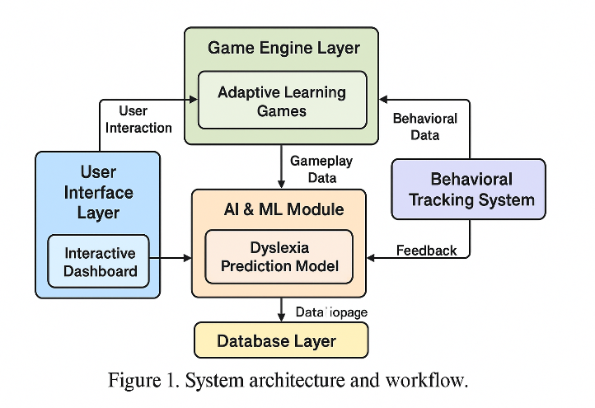
Figure 1. Overall System Architecture

2.3 ARTIFICIAL INTELLIGENCE IN DYSLEXIA DETECTION
Researchers can now make automated systems that use computer analysis to find dyslexia thanks to recent advances in artificial intelligence. Machine learning techniques have been applied to various data types, including handwriting samples, reading habits and eye movement patterns. These methods look for patterns that make dyslexic learners different from non-dyslexic learners so that they can be found and helped early.
Handwriting analysis is a very useful way to predict dyslexia. Changes in the way letters are made, spaced and written could be signs of differences in how the brain works. Convolutional neural networks (CNNs) have demonstrated promising efficacy in identifying dyslexic characteristics and extracting visual components from handwriting images.
Standard machine learning metrics like accuracy, precision, recall and F1-score are commonly used to evaluate these models. Table 3 summarizes the performance comparison of various detection approaches and shows that the suggested CNN-based strategy outperforms previous machine learning techniques in terms of prediction accuracy. These findings suggest that complicated handwriting patterns linked to dyslexia can be efficiently captured by deep learning methods.

2.4 COMPARATIVE ANALYSIS AND RESEARCH GAP
Even though dyslexia research has come a long way, most of the current methods only deal with a small part of the problem. Structured reading activities and phonological instruction are the main parts of traditional remediation programs. Even though these methods can help students improve their reading and writing skills, they often don't keep their interest for long periods of time.
Many gamified educational products don't have adaptive features or full behavioral tracking, but they do try to get people more involved by including interactive activities. AI-based diagnostic systems, on the other hand, can make predictions, but they are usually made to work on their own and not as part of interactive learning environments.
Table 1 compares different strategies and shows the pros and cons of gamified tools, AI-based detection methods and traditional ways to fix problems. As the table shows, none of the current options address cognitive skill development, emotional involvement and predictive analysis all at once on the same platform.
This difference shows how important it is to have a single solution that combines cognitive analytics and interactive learning. The proposed Dyslexis platform, whose architecture is shown in Figure 1, aims to close this gap by bringing together gamified learning modules, behavioral tracking systems and AI-driven handwriting prediction into a single supportive learning environment. This combined approach makes learning fun and adaptable for students while also helping them develop skills and find out if they have dyslexia early on.
Invention Approach | Evaluation Criteria
Invention Approach | Focus Area | Advantages | Limitations
Traditional Remediation | Phonological Training | Proven reading improvement | Low engagement, no personalization
Gamified Tools | Motivation , Retention | High interactivity, accessible | Poor adaptivity, limited
AI Based systems | Data driven Prediction | Personalized insights, automation | Lack of emotional, behavioural context
Table 1. Comparison Of Approaches

CHAPTER 3
PROPOSED METHODOLOGY

3.1 SYSTEM ARCHITECTURE
Dyslexis platform have a modular architecture which includes five main components:
- User Interface Layer – Web based dashboard for students, parents and therapists to assist the platform.
- Game Layer – It includes multiple adaptive games for better learning.
- AI & ML Module – It predicts the probability of being dyslexic through quiz, handwriting analysis and game scores.
- Behavioural Tracking System – It monitors user’s engagement and their learning curves.
- Database Layer – It stores progress reports, feedback and learning outcomes that comes from the games.

DATA PROCESSING & MACHINE LEARNING
- Handwriting Input: Image of person’s handwriting is uploaded to the model [17].
- Model Evaluated: It predicts the probability of Dyslexia through a CNN model and follows logistic regression.
- Behavioural Metrics: Accuracy levels, response time and emotional cues are also measured through game scores [18].

3.3 GAMIFICATION DESIGN PRINCIPLES
- Claim Until You Gain – Positive rewards like points, badges and achievements is given to encourage growth and involvement.
- Adaptive Difficulty – Activities change as they sense a user’s skills improving or declining.
- Positive Feedback Cycle – Visual and sound signals to enhance learning.

MATHEMATICAL FORMULATIONS
Let the handwriting image dataset be defined as:
Where
- ^{H×W×C} represents the ^{th} handwriting image,
- denotes the class label (0 = non-dyslexic, 1 = dyslexic),
- and is the total number of samples
The CNN model learns a parametric mapping:
where represents the trainable parameters of the network and is the predicted probability of dyslexia.
3.4.1 Loss Function (Binary Cross Entropy)
The model is trained using Binary Cross-Entropy (BCE) loss defined as:
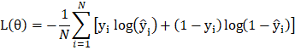
This loss function penalizes incorrect predictions while maximizing classification confidence.
3.4.2 Optimization Strategy
The model parameters are optimized using the Adam optimizer. Parameter updates are computed as:
Where
- α is the learning rate
- is the gradient of the loss function
- denotes the training iteration
For completeness, Adam updates are computed using:
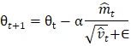
Where

DATASET DESCRIPTION
The handwriting dataset used in this study was obtained from a publicly available repository on Kaggle. [17] The dataset consists of handwritten text samples collected from school-age students and labeled as dyslexic and non-dyslexic. All images were resized to 224 × 224 pixels prior to training. The dataset was divided into 80% training data and 20% testing data. To improve model generalization and reduce overfitting, data augmentation techniques such as random rotation, zooming and brightness adjustment were applied during training.
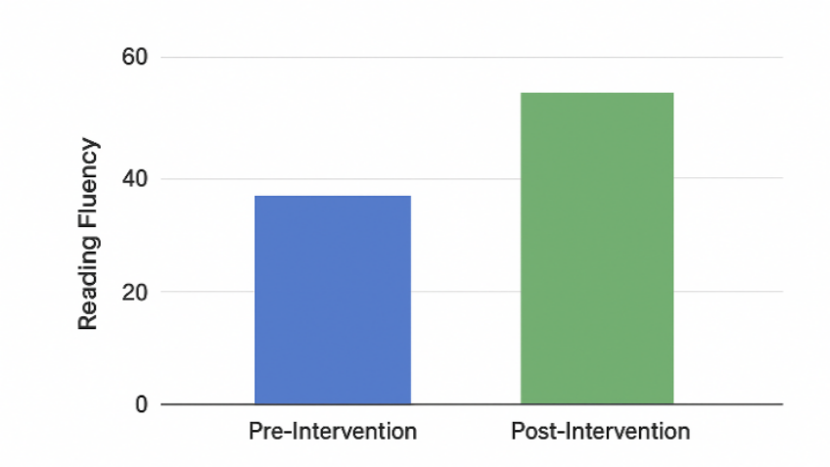
Fig. 2. Impact Of Proposed Solution On Reading Fluency

3.6 GAME MODULES (FIVE CORE GAMES)
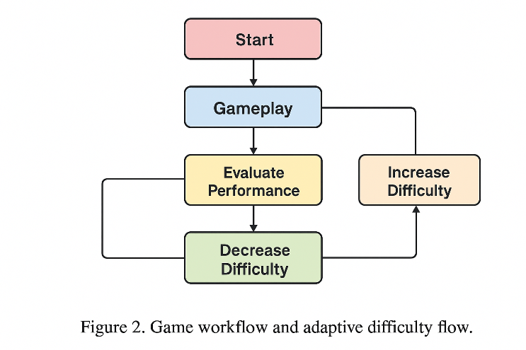
Fig. 3. Game And Adaptive Difficulty Flow

Game | Focus Area | Description
PhonoMatch | Phonological Awareness | Users match sounds to letters using audio cues.
WordBuilder | Vocabulary & Spelling | Drag-and-drop letters to form words, reinforcing spelling patterns.
ShapeTracer | Visual-Motor Coordination | Traces alphabets or words using AR overlays and gesture recognition.
StorySprint | Reading Comprehension | Interactive stories with timed comprehension questions.
EmotionQuest | Emotional & Behavioral Training | Reinforces emotional recognition through expressive avatars and rewards.

Table 2. Proposed Game Based Modules

EVALUATION FRAMEWORK
The platform is tested with group of students (age between 8–14) which are affected with mild to moderate dyslexia. Their progress is measured based on speed, accuracy, memory and emotional resilience over 8 weeks.

3.8 SYSTEM SCREENS (WEBSITE OVERVIEW)
The Dyslexis platform includes an intuitive and child-friendly interface. The following screenshots illustrate key components of the system interface such as the homepage, game dashboard, handwriting upload panel and behavioural tracking screen. This visual layout help in ensuring easy navigation and accessibility (for learners, teachers and parents).
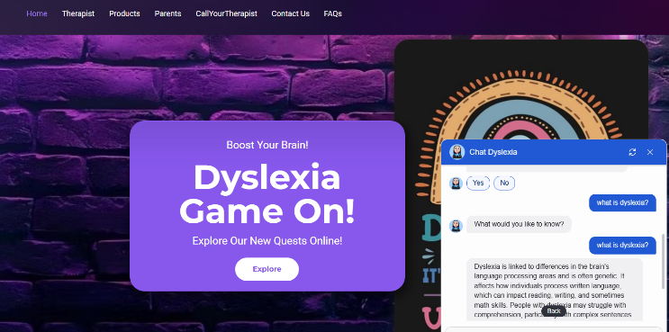
Fig. 4 The Gamified Learning Interface.

3.9 TECHNOLOGY STACK
The Dyslexis platform was made with a mix of web-based and AI-driven technologies. HTML, CSS and JavaScript are used for the frontend interface and WIX is used for quick web prototyping and layout structuring. Using Scratch-based visual prototyping and Unity, we were able to quickly test cognitive tasks by simulating game mechanics and learning interactions. Roboflow was used to create the dataset annotation, preprocessing, augmentation and training pipeline for the AI module. TensorFlow (Keras) was used to build the model. The platform has a conversational assistant made with Botpress that lets users get personalized help. This tech stack works together to make AI-driven adaptive learning flexible, fast to develop and strong.
CHAPTER 4
RESULTS AND DISCUSSION

We looked at the proposed Dyslexis platform to see how well the gamified learning environment worked and how well the AI-based handwriting prediction model worked. The evaluation primarily assessed enhancements in learning engagement, reading-related cognitive abilities and the precision of dyslexia identification via handwriting analysis. The system was tested with handwriting datasets and by having dyslexic learners interact with the gamified modules.

4.1 PERFORMANCE OF THE HANDWRITING PREDICTION MODEL
The handwriting classification model was implemented using a convolutional neural network (CNN) and trained on a labeled dataset of hsndwritten alphabets. Standard machine learning metrics measure the performance of the model, including accuracy, precision, recall, F1-score, validation loss and ROC-AUC score.
The result obtained from the trained model is summarized in Table 3. The model achieved an accuracy of 84.6%, demonstrating its ability to identify patterns in handwriting that are associated with dyslexia. The precision value of 0.82 indicates that the system correctly identifies dyslexic samples with a high degree of reliability, while the recall score 0.80 shows that the model is capable of detecting most of the relevant cases present in the dataset. The F1-score of 0.81 reflects a balanced trade-off between precision and recall, indicating consistent classification performance.
The ROC-AUC value of 0.87 also demonstrates the model’s capability to distinguish between dyslexic and non-dyslexic handwriting samples from different decision thresholds. These results shows that the proposed CNN-based approach is effective in capturing handwriting features relevant to dyslexia detection.

4.2 COMPARATIVE ANALYSIS WITH EXISTING METHODS
To evaluate the effectiveness of the proposed model, its performance was compared with previously used machine learning approaches used for dyslexia detection. The comparison is shown in Table 4, which includes traditional machine learning techniques, hybrid deep learning models and the our proposed CNN-based solution.
Earlier approaches such as Support Vector Machine (SVM) classifiers achieved an accuracy of approx 78%, while recent machine learning-based classifiers shows an accuracy of around 82%. Hybrid deep learning approaches such as CNN-LSTM models have achieved accuracy levels of sround 83%. In comparison, the proposed CNN model achieved 84.6% accuracy, which shows a measurable improvement over earlier techniques.
This improvement can be attributed to the use of convolutional layers that effectively capture spatial features present in handwriting patterns. By learning visual characteristics such as stroke formation, spacing irregularities and structural variations in characters, the CNN model is able to provide more accurate predictions than traditional feature-based methods.

4.3 IMPACT OF GAMIFIED LEARNING MODULES
Beyond the prediction model, the Dyslexis platform was designed to enhance learning engagement and improve cognitive development through gamified activities. The interactive learning modules were developed to address learning challenges associated with dyslexia, which includes phonological awareness, reading comprehension, memory retention and visual-motor coordination.
Students interacting with the platform demonstrated improved engagement levels due to the reward-based learning structure. Features such as points, badges and adaptive difficulty encouraged continuous participation and helped maintain learner motivation. The behavioural tracking system recorded metrics such as response time, accuracy and completion rates during gameplay, allowing the platform to monitor individual learning progress.
The adaptive game flow illustrated in Figure 2 allows the system to adjust the complexity of tasks according to the learner’s performance. When students perform well, the difficulty level increases simultaneously, while lower performance triggers simpler tasks and additional guidance. This adaptive mechanism helps ensure that learners are neither overwhelmed nor under challenged during the learning process.

4.4 EDUCATIONAL AND PRACTICAL IMPLICATIONS
The result demonstrate that integrating artificial intelligence with interactive gamified learning environments can create a more better support system for dyslexic learners. The predictive handwriting model provides early identification of dyslexia risk, while the gamified modules simultaneously support skill development and emotional engagement.
Additionally, the behavioural tracking and reporting features of the platform allow educators and parents to monitor student progress more effectively. By providing structured progress reports and performance insights, the system enables timely interventions and personalized learning strategies.
Overall, the results indicate that the Dyslexis platform offers a promising approach for combining early detection and interactive learning within a single digital ecosystem. This integrated framework not only improves accuracy but also promotes a more engaging and supportive learning experience for dyslexia students.

Metric | Value
Accuracy | 84.6%
Precision | 0.82
Recall | 0.80
F1-Score | 0.81
Validation Loss | 0.42
ROC-AUC | 0.87
Table 3. Performance Metric Of Proposed Model

Model | Year | Method | Accuracy
Traditional ML (Tsai & Wu) | 2021 | SVM | 78%
Velmurugan | 2023 | ML Classifier | 82%
Hybrid CNN-LSTM | 2024 | Deep Learning | 83%
Proposed Method | 2025 | CNN | 84.6%

Table 4. Comparative Performance Analysis Of Dyslexia Detection Models

CHAPTER 5
CONCLUSION AND FUTURE SCOPE

5.1 CONCLUSION
This study presented Dyslexis, an integrated gamified learning platform designed to support children with dyslexia by combining interactive educational games with artificial intelligence–based handwriting analysis. To achieve, the author proposed an integrated learning and prediction system for dyslexia combining adaptive educational games with a CNN-based handwriting classification. From this model, an accuracy of 84.6% was achieved on the test dataset, indicating that AI-based screening can be embedded in interactive learning platforms assessing students' multiple performance metrics along with their academic outcomes. While promising, these results need to be studied further in larger and clinically validated datasets. In future work, this process will be integrated with real-time emotional analytics and provide support for multilingual learning environments. For maximising impact and scaling Dyslexic in the future, there are some critical improvements. One of the focuses is to provide a complete AR/VR system to make interactive education immersive, which will need multi-sensory input. Try to be intuitive, and if possible, try to make it fun so the dyslexic readers do not find it boring or hard, but emotional. As it can be applied in actual clinical trials by collaborating with educational psychologists and clinical specialists, this platform suggests actionable improvements of proven effectiveness and adaptability. An integrated aspect of the emotional recognition AI will enable this system to also detect real-time engagement and moods, responding accordingly with empathetic attention based on the emotions shown by an individual. Collecting such an open-access dataset enable the community working on research and inform opportunities for clinical translation throughout this domain of investigation.
Overall, the Dyslexis platform demonstrates the potential of combining gamification, behavioural analytics and machine learning within a unified system. By integrating learning support and predictive analysis, the system contributes toward the development of more inclusive and technology-driven educational solutions for students with learning disabilities.

5.2 FUTURE SCOPE
Although the proposed system shows promising results, several enhancements can further improve its effectiveness. One potential direction is the integration of augmented reality (AR) and virtual reality (VR) technologies to create more interactive learning experience. Such multi-sensory environments can help dyslexic learners play with letters, sounds and words in a more engaging and intuitive manner.
Another important extension is the development of multilingual support, allowing the platform to assist learners from diverse linguistic backgrounds. Expanding the system to support regional languages would make it more accessible in countries with multilingual education systems.
Future research can also explore the integration of emotion recognition technologies to analyze facial expressions or voice patterns during learning activities. This would enable the platform to adapt its content dynamically according to the learner’s emotional state, improving personalization and engagement.
Additionally, large-scale clinical validation involving educators, psychologists and special education professionals can help refine the predictive models and validate the platform’s effectiveness in real educational environments. Creating an open-access handwriting dataset for dyslexia research could also contribute to broader academic and clinical studies in this domain.
In the long term, the Dyslexis framework can be extended to support other neurodevelopmental learning conditions such as ADHD, dysgraphia and language processing disorders, thereby expanding the role of assistive technologies in inclusive education.

REFERENCES
[1] J. H. Smith-Spark and J. E. Fisk, “Working memory functioning in developmental dyslexia,” Memory, vol. 15, no. 1, pp. 34–56, 2007.
[2] M.-L. Bosse, M. J. Tainturier and S. Valdois, “Developmental dyslexia: The visual attention span deficit hypothesis,” Cognition, vol. 104, no. 2, pp. 198–230, 2007.
[3] B. A. Shaywitz and S. E. Shaywitz, “Dyslexia (specific reading disability),” Biological Psychiatry, vol. 57, no. 11, pp. 1301–1309, 2005.
[4] Nora Maria Raschle, Maria Chang, Nadine Gaab, Structural brain alterations associated with dyslexia predate reading onset, NeuroImage,Volume 57, Issue 3,2011,Pages 742-749,ISSN 1053-8119
[5] Stoodley, C.J., Stein, J.F. Cerebellar Function in Developmental Dyslexia. Cerebellum 12, 267–276 (2013).
[6] A. D. Baddeley, “Working memory,” Science, vol. 255, no. 5044, pp. 556–559, 1992.
[7] A. D. Baddeley, “Working memory: Looking back and looking forward,” Nature Reviews Neuroscience, vol. 4, no. 10, pp. 829–839, 2003.
[8] H. L. Swanson and M. Hoskyn, “Interventions for children with learning disabilities: A meta-analysis of treatment outcomes,” Review of Educational Research, vol. 71, no. 2, pp. 171–224, 2001.
[9] J. C. Ziegler and U. Goswami, “Reading acquisition, developmental dyslexia and skilled reading across languages: A psycholinguistic grain size theory,” Psychological Bulletin, vol. 131, no. 1, pp. 3–29, 2005.
[10] Frith, U. (1999) Paradoxes in the definition of dyslexia. Dyslexia, 5(4).pp.192-214. ISSN 10769242.5. 10.1002/ (SICI)1099-0909(199912)5:43.0.CO;2-N.
[11] M. Wolf, Proust and the Squid: The Story and Science of the Reading Brain, New York, NY, USA: HarperCollins, 2007.
[12] M. Pellegrino, T. D. Ben-Soussan and P. Paoletti, “A scoping review on movement, neurobiology and functional deficits in dyslexia: Suggestions for a three-fold integrated perspective,” International Journal of Environmental Research and Public Health, vol. 20, no. 4, p. 3315, 2023.
[13] S. V. Di Pietro, D. Willinger, N. Frei, C. Lutz, S. Coraj, C. Schneider, P. Stämpfli and S. Brem, “Disentangling influences of dyslexia, development and reading experience on effective brain connectivity in children,” NeuroImage, 2023, Art. no. 119869.
[14] S. Velmurugan, “Predicting dyslexia with machine learning: A comprehensive review of feature selection, algorithms and evaluation metrics,” Journal of Behavioural Data Science, vol. 3, no. 1, pp. 70–83, 2023.
[15] R. Hernández-Vásquez, U. Córdova García, A. M. B. Barreto, M. L. Rodriguez Rojas and J. Ponce-Meza, “An overview on electrophysiological and neuroimaging findings in dyslexia,” Iranian Journal of Psychiatry, vol. 18, no. 4, pp. 348–362, 2023.
[16] Rello, Luz & Baeza-Yates, Ricardo. (2013). Good fonts for dyslexia. Proceedings of the 15th International ACM SIGACCESS Conference on Computers and Accessibility, ASSETS 2013. 10.1145/2513383.2513447.
[17] Kaggle, “Dyslexia Handwriting Dataset,” Available at: https://www.kaggle.com/datasets/drizasazanitaisa/dyslexia-handwriting-dataset (accessed 2024).
[18] C. C. L. Tsai and T. R. Wu, “Using machine learning to support early identification of dyslexia,” Computers & Education, vol. 166, p. 104146, 2021.

APPENDIX 1
This appendix provides additional technical information related to the dataset preparation, system implementation, model configuration and evaluation setup which is used in the development of this platform. These details complement the methodology described in the main paper and provide further clarity regarding the experimental design and system architecture.

A. Dataset Preparation and Preprocessing
The handwriting dataset used for dyslexia prediction consists of labeled handwriting samples collected from school-age students. Each sample represents handwritten text alphabet captured as an image and labeled according to whether the writer is dyslexic or non-dyslexic.
Before training the model, several preprocessing steps were performed to ensure consistency and to improve model performance:
- All images were resized to 224 × 224 pixels to match the input requirements of the convolutional neural network.
- Pixel normalization was applied to scale image values to a standardized range, improving training stability.
- Data augmentation techniques such as random rotation, zooming, brightness adjustment and horizontal shifting were applied to increase dataset variability and reduce overfitting.
- The dataset was divided into 80% training data and 20% testing data to evaluate model generalization on unseen samples.
These preprocessing steps helped improve model robustness and ensured that the training process captured diverse handwriting patterns.

B. CNN Model Configuration
The handwriting prediction system is based on a Convolutional Neural Network (CNN) architecture designed to extract visual features from handwriting images. The model includes multiple convolutional layers followed by pooling layers that reduce spatial dimensions while preserving important structural features of handwriting patterns.
It’s architecture consists of:
- Convolution Layers: Extract low-level and high-level visual features such as stroke thickness, spacing and character structure.
- Pooling Layers: Reduce dimensionality and improve computational efficiency.
- Fully Connected Layers: Perform classification based on extracted features.
- Output Layer: Uses a sigmoid activation function to predict the probability of dyslexia.
The model was trained using the Binary Cross-Entropy loss function and optimized using the Adam optimizer, which adapts learning rates dynamically during training to improve convergence.

C. Hyperparameter Settings
The following hyperparameters were used during training of the model:
- Image Input Size -- 224 × 224
- Batch Size -- 32
- Learning Rate -- 0.001
- Optimizer -- Adam
- Loss Function -- Binary Cross Entropy
- Training Epochs -- 25
These parameters were selected after experimentation of balance training efficiency and prediction accuracy.

D. Gamified Learning Modules
The Dyslexis platform includes five educational games which are designed to strengthen different cognitive abilities associated with dyslexia. These modules focus on improving phonological awareness, spelling ability, reading comprehension, motor coordination and emotional engagement.
The learning modules include:
- PhonoMatch: Improves phonological awareness through sound-to-letter matching activities.
- WordBuilder: Reinforces vocabulary and spelling through drag-and-drop word formation tasks.
- ShapeTracer: Enhances visual-motor coordination by allowing learners to trace letters and words.
- StorySprint: Develops reading comprehension through interactive storytelling and timed questions.
- EmotionQuest: Supports emotional recognition and behavioural training through expressive avatars and feedback systems.
Each game have adaptive difficulty mechanisms, allowing the system to adjust the complexity of tasks based on learner’s performance.

E. Behavioural Tracking Metrics
The platform includes a behavioural monitoring system that records user interaction data during gameplay. The following metrics are collected:
- Response Time: Time taken by the learner to complete each task.
- Accuracy Rate: Percentage of correct responses in learning activities.
- Completion Rate: Number of successfully completed game levels.
- Engagement Frequency: Number of interactions and active participation sessions.
These metrics are analyzed to generate personalized progress reports that assist teachers and parents in understanding the learner’s development.

F. System Implementation Environment
The Dyslexis platform was implemented using a combination of web development technologies and machine learning frameworks:
- Frontend: HTML, CSS , JavaScript, React for interactive user interface design.
- Game Prototyping: Unity and Scratch for interactive educational game development.
- Machine Learning Framework: TensorFlow with Keras for CNN model training and evaluation.
- Dataset Processing: Roboflow for dataset annotation, preprocessing and augmentation.
- Conversational Support: Botpress for integrating a chatbot to assist users during interaction.
This integrated technology stack ensures flexibility, scalability and efficient deployment of the gamified learning platform.

G. Evaluation Setup
The proposed system was evaluated using both machine learning performance metrics and educational engagement indicators. The CNN model was assessed using accuracy, precision, recall, F1-score, validation loss and ROC-AUC metrics. In addition, the effectiveness of the gamified modules was evaluated by analyzing improvements in learner’s engagement, task completion rates and response accuracy over time.
These supplementary details provide additional insight into the technical implementation and evaluation of the Dyslexis platform and support the findings presented in the main study.

RESEARCH PAPER

PROOF OF SUBMISSION/ACCEPTANCE/PUBLICATION

PLAGIARISM REPORT

